Last Name: ____________ First Name: ____________ Date: _______ Class: BIO3 Section: ________
Assignment 3 - Metabolism and Photosynthesis
Discussion
Research for a university student is very important because it opens the minds of the student to new things such as study on the algae. The institution gives the student to learn more due to support from the agricultural faculty and other department in sciences with applied sciences that provides for diverse research. Algae can be used to provide biofuels that is used to provide energy this is from the oil produced from algae. In future machines using gasoline and diesel could also use fuel from algae.
- How effective would be the energy from algae fuel?
- What would be the effect on increased use of algae fuel?
- Would adoption of algae fuel be cost saving to the users?

- Contrast kinetic energy and potential energy by explaining how they are different.
Kinetic energy is energy found in a moving object while potential energy is that energy in an object that is not in motion.

- List 2 examples of kinetic energy and 2 examples of potential energy.
• Kinetic energy:
- A truck travelling down the hill

2. Water in a river flowing due to velocity

• Potential energy:
1. Electric energy

- Nuclear energy

- Draw a diagram of a molecule of ATP. Label ALL of the following: ribose sugar, adenosine, phosphate, high-energy bonds.
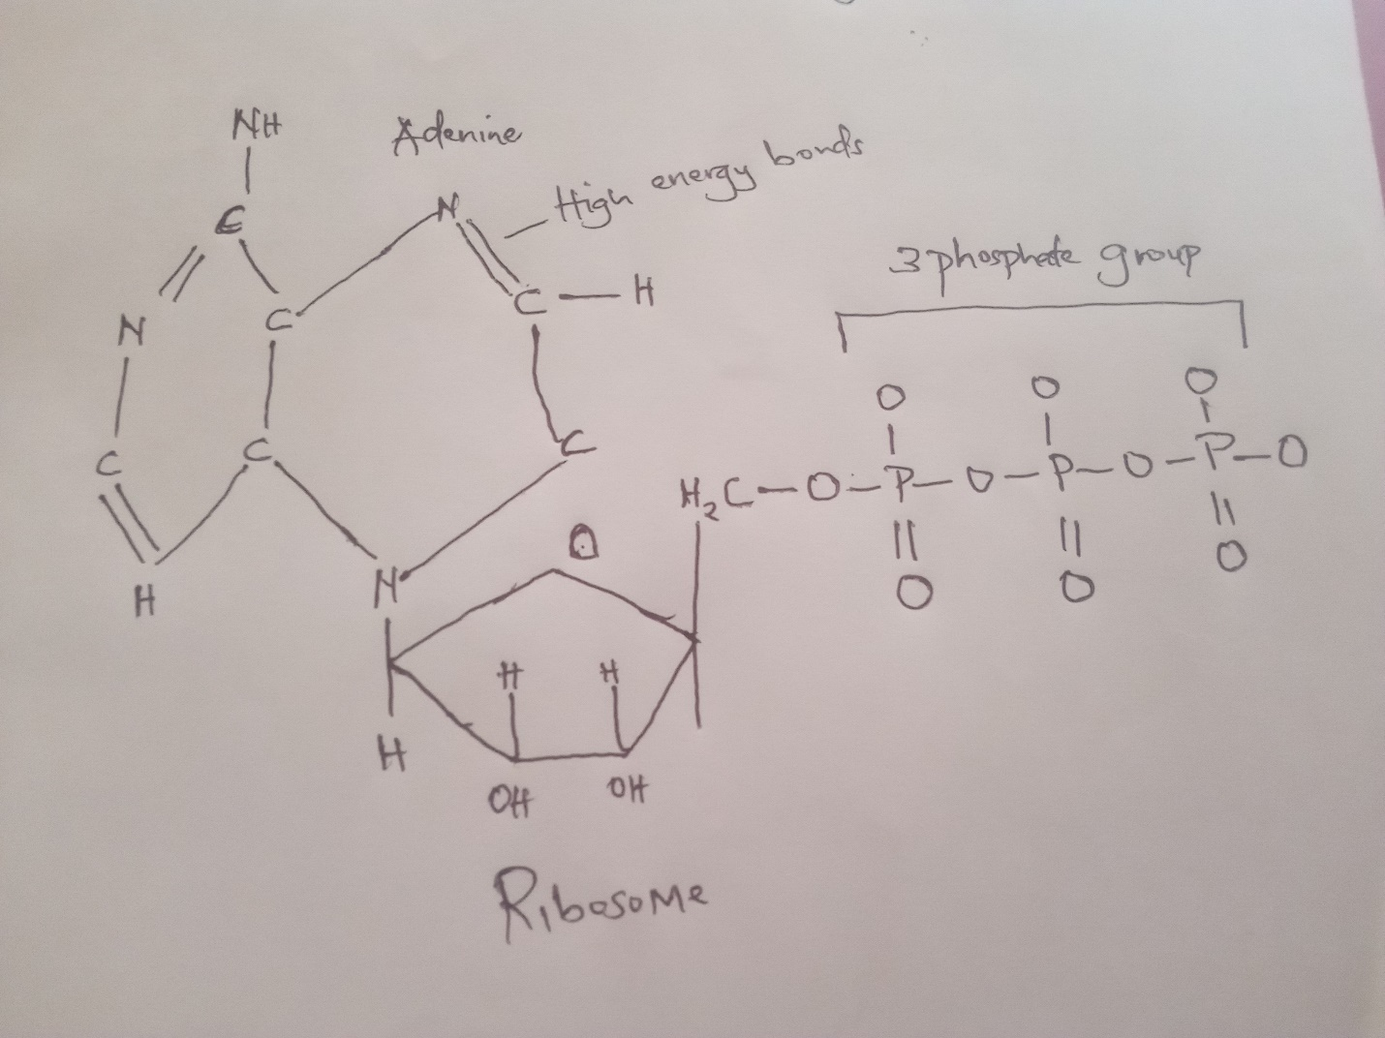

4. Are the high-energy bonds between the phosphate groups in ATP a form of potential energy or kinetic energy? The bonds have high kinetic energy that is used to move the components of the molecule
5. Explain what happens when the terminal phosphate group in ATP is hydrolyzed. Use ALL of the following words in your explanation: ATP, terminal phosphate group, ADP, Pi, energy, work. Underline or highlight each term.
ATP molecule is hydrolyzed to ADP. For hydrolysis to take place water is a reagent.
The product of the hydrolysis will have ADP,P_{I} which is organic phosphate group.
6. Use the following T-chart to contrast characteristics of producers and consumers, showing how they are different.
Producers | Consumers
Definition  This are organisms make their own food from chemicals with the help of water to convert energy into usable energy inform of food | Definition  This are leaving creatures that depend on organism for food.
List 3 examples of organisms that are producers | List 3 examples of organism that are producers
1.fruits | 1.carnivores
2.algae | 2.herbivores
3.green plants | 3.omnivores

7. Define photosynthesis:
Process by which green plants use light to synthesis nutrients from carbon dioxide with the help of chlorophyll and generates oxygen as a bi product.
8. Complete the following overall chemical equation for photosynthesis by writing in the chemical formula where underlined and the name of the molecule within the parentheses.
6 CO2 (carbon dioxide) + 6 _H₂O___(water) ! C6H12O6 (sugar ) + 6 O2 (oxygen )

9. In which organelle in plants does photosynthesis take place?
Chloroplasts. This is surrounded by double membrane and thylakoid membrane that forms folds with the organelle
10. Analyze the structure of a chloroplast by drawing a diagram of a single chloroplast. Label ALL of the following in your diagram: outer membrane, inner membrane, stroma, thylakoid, granum.
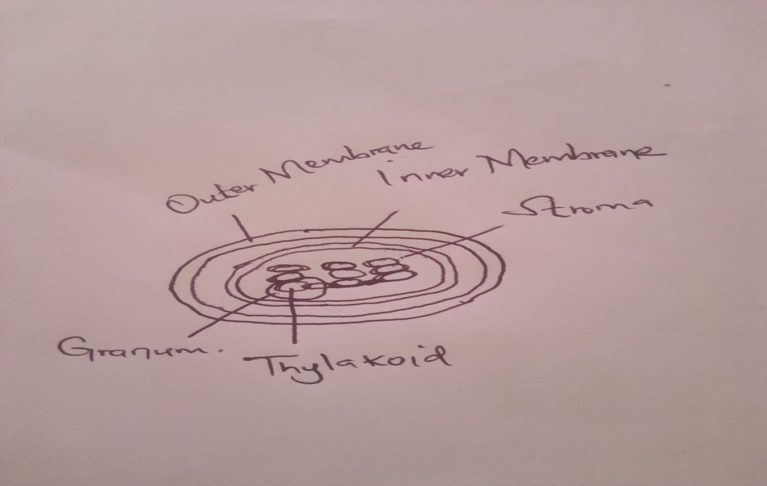
11. During photosynthesis, where does the light reaction occur? Thylakoid discs
12. During photosynthesis, where does the dark reaction occur? This takes place in the chloroplasts stroma

13. Circle the color of visible light absorbed by chlorophyll?
Red
Orange
Yellow
Green
Blue
Indigo
Violet
14. Circle the color of visible light transmitted (reflected) by chlorophyll?
Red
Orange
Yellow
Green
Blue
Indigo
Violet
15. Once chlorophyll in Photosystem II has absorbed energy from visible light, what happens to this energy? Write an explanation using ALL of the following terms: water, oxygen, hydrogen ions, Photosystem II, light, energy, electron transport chain, stroma, thylakoid space. Underline or highlight each term organism capture light and hydrogen ions that are used in making energy. In the process water is oxidized to oxygen and carbon dioxide glucose. Light dependent reaction takes place in thylakoid membrane while the light independent takes place in stroma. Electron transport chains is embedded in the inner mitochondrial shuttles electrons during the process. Hydrogen ions build up in the thylakoid membrane electrons move to the photosystem ii .
16. The concentration of hydrogen cations (H+) is high in the thylakoid of the grana compared the low concentration of H+ in the of the chloroplast. This is because water is hydrolyzed by carbon dioxide _and is pumped into the thylakoid space by the electron transport chain. The H+ moves passively down its gradient through the concentration gradient which is where ATP is made.
17. Photosystem I receives electrons from the electron transport chain and excites this electron using energy collected from chlorophyll in Photosystem I. Explain how the energy in Photosystem I is used. Use ALL of the following in your explanation: Photosystem I, chlorophyll, light, energy, NADP+ , NADPH. Underline or highlight each term.
Chlorophyll absorb light for photosynthesis to take place .Photosystem 1 provides reducing power to reduce NADP to NADPH required for photosynthesis. In the day light photosystem 1 has a high reducing power.
18. The NADPH and ATP produced in the light reaction of the photosynthesis is used in the dark reaction to make
They are used to fix carbon dioxide the end products are sugar molecules necessary for cell function and metabolism.
19. Plants receive water for photosynthesis by absorbing it from the ground through roots. The water moves upward through the plant’s stems and leaves due to xylem vessels.
20. The dark cycle of photosynthesis occurs in the stroma of the chloroplast.
21. Overall the point of the dark cycle is to make sugar using ATP synthesized in the photosystem reaction, ATP made in the light reaction, and carbon dioxide that enters leaves through small holes called stomata.
22. Explain how gaseous carbon dioxide (CO2) is changed or “fixed” into solid carbon dioxide that can be used in the dark reaction. Use ALL of the following terms: carbon dioxide, ribulose bisphosphate, ribulose bisphosphate carboxylase (RuBisCO), 3-phosphoglycerate
Carbon dioxide from the environment are absorbed through the stomata of the leaves. Ribulose bisphosphate and carbon dioxide join and create a molecule 3-phosphoglycerate. In the first carbon fixation results to formation of ribulose bisphosphate carboxylase (RuBisCO)
23. Once glyceraldehyde 3-phosphate (G3P) is made in the dark reaction, it moves to the cytosol of the plant cell, where it is converted into sucrose
24. List 3 ways that plants use glucose:
• Respiration
• Protein synthesis
•cellulose making

